
Note on Local Government Reorganisation

Local Government Reorganisation – The Context

  - Central Government has an ambition to ‘simplify local government, by ending the two-tier system and establishing new single-tier unitary councils’ to create ‘stronger local councils empowered across local services, equipped to drive economic growth, improve local public services and empower their communities’.

  - Central Government launched its public consultation on Local Government Reorganisation in Kent & Medway on 5 February 2026. The consultation closes on: 26 March 2026.

  - The consultation asks for the public’s views on the boundaries for the new unitary authority/authorities - that will replace Kent County Council, Medway Council, and the 12 district councils.

  - The Kent Council Leaders have worked constructively together to come up with potential new boundaries. This is a sign of the maturity of Kent and Medway, as we understand that our area is the only one in the UK which has maintained constructive dialogue and joint working of all local authorities throughout the process.

  - There are five boundary models for the public to consider (overview on next page).

  - Here is the link to the consultation which sets out the proposals in much greater depth: Proposals for local government reorganisation in Kent and Medway - GOV.UK

Next Steps:
  - The KMEP Chairman wishes to propose that each KMEP board member responds individuals to the consultation with their own views on boundaries, as there are clearly differences in individuals’ views. However, from current conversations, the Chairman understands that there is a strong unified desire to see devolution delivered to the area – so Kent & Medway can benefit from the devolved powers and funding that mayoral strategic authorities benefit from.

  - At the board member, the KMEP Chairman would therefore wish to seek the board’s approval to submit one joint response to this consultation – that does not express a preference for one of the five models – but rather unambiguously emphasises the need for devolution. This proposal will be explained during the board meeting.

  - Finally, for reference, the KMEP Chairman has previously written to Ministers asking for Kent & Medway to be considered for devolution. The recent response from MHCLG Ministers on this issue says: ‘Following the ministerial reshuffle, we have been taking stock of where mayoral devolution is most successful. We believe it works best when underpinned by strong and stable unitary structures. The reorganisation process should therefore conclude before Mayors are elected and the full suite of mayoral powers are unlocked.

  - The Government believes that Mayoral Strategic Authorities are also most successful when built on a strong history of partnership and joint delivery. Moving forward, we will therefore seek to facilitate the establishment of Foundation Strategic Authorities to build local capacity ahead of areas accessing mayoral powers. These Foundation Strategic Authorities will be empowered to deliver for their residents in the interim’.

Proposal | One Unitary Authority (with three area assemblies):  - Kent & Medway combined | Three Unitary Authorities:  - North: Dartford, Gravesham, Medway, Swale  - West: Maidstone, Sevenoaks, Tonbridge & Malling, Tunbridge Wells  - East: Ashford, Canterbury, Dover, Folkestone & Hythe, Thanet | Four Unitary Authorities:  - North: Dartford, Gravesham, Medway  - West: Maidstone, Sevenoaks, Tonbridge & Malling, Tunbridge Wells  - Mid: Swale, Ashford, Folkestone & Hythe  - East: Canterbury, Dover, Thanet | Four Unitary Authorities:  - North Kent: Medway (98%), Gravesham (87%), Swale (81%), Dartford (78%), small parts of Tonbridge and Malling (3%), Maidstone (2%)  - West Kent: Sevenoaks, Tunbridge Wells, Tonbridge and Malling (61%), Dartford (22%), Gravesham (13%), Medway (2%)  - East Kent: Canterbury, Dover, Thanet, Folkestone and Hythe (64%), Swale (Faversham area 17%)  - Mid Kent: Ashford, Maidstone (98%), Folkestone and Hythe (36%), Tonbridge and Malling (36%), Swale (3%) | Five Unitary Authorities:  - North Kent: Dartford, Gravesham, Medway (25%), and Sevenoaks (18%)  - West Kent: Maidstone, Sevenoaks (82%), Tonbridge and Malling, and Tunbridge Wells  - East Kent: Canterbury, Swale (24%), and Thanet  - Mid Kent: Medway (75%) and Swale (76%)  - South Kent: Ashford, Dover, and Folkestone & Hythe
Map | 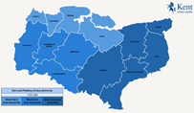 | 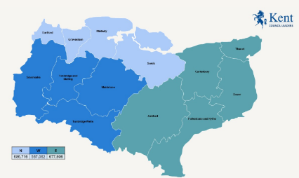 | 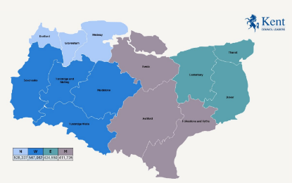 | 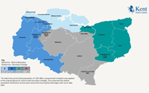 | 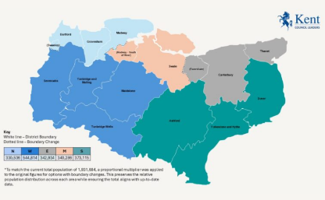
Support  from: | - Kent County Council | - Folkestone & Hythe District Council  - Maidstone Borough Council  - Sevenoaks District Council  - Tonbridge & Malling BC.  - Tunbridge Wells BC. | - Dover District Council,  - Swale Borough Council,  - Thanet District Council | - Medway Council  - Ashford Borough Council  - Canterbury City Council | - Dartford Borough Council  - Gravesham Borough Council
Popul.  Range | - 1.93m | - 567k to 687k | - 411k to 567k | - 374k to 616k | - 331k to 545k

Local government reorganisation: Policy and programme updates - GOV.UK

